
Whitepapers

ASP.NET Starter Kit: Commerce
October 2002

© 2002 Microsoft Corp. All rights reserved.
The information contained in this document represents the current view of Microsoft Corp. on the issues discussed as of the date of publication. Because Microsoft must respond to changing market conditions, it should not be interpreted to be a commitment on the part of Microsoft, and Microsoft cannot guarantee the accuracy of any information presented after the date of publication.
This white paper is for informational purposes only. MICROSOFT MAKES NO WARRANTIES, EXPRESS OR IMPLIED, AS TO THE INFORMATION IN THIS DOCUMENT.
Complying with all applicable copyright laws is the responsibility of the user. Without limiting the rights under copyright, no part of this document may be reproduced, stored in or introduced into a retrieval system, or transmitted in any form or by any means (electronic, mechanical, photocopying, recording or otherwise), or for any purpose, without the express written permission of Microsoft.
Microsoft may have patents, patent applications, trademarks, copyrights or other intellectual property rights covering subject matter in these documents. Except as expressly provided in any written license agreement from Microsoft, the furnishing of this document does not give any license to these patents, trademarks, copyrights or other intellectual property.
Microsoft, Visual Studio, Windows, IntelliSense, Visual Basic, Visual C#, MSDN, Windows NT, and JScript are either registered trademarks or trademarks of Microsoft Corp. in the United States and/or other countries.
The names of actual companies and products mentioned herein may be the trademarks of their respective owners.
Microsoft Corp. • One Microsoft Way • Redmond, WA 98052-6399 • USA

ASP.NET Commerce Starter Kit: Design and Implementation
Vertigo Software, Inc.
October 2002
Summary: This article describes the design and architecture decisions for the Commerce Starter Kit application. In addition, a detailed look and explanation of the implementation is also covered. (20 printed pages)

Overview

What is the Commerce Starter Kit?
The Commerce Starter Kit is an e-commerce storefront selling fictional spy equipment. The application demonstrates basic online shopping tasks including: a product catalog, user authentication and personalization, shopping baskets, and order checkout.
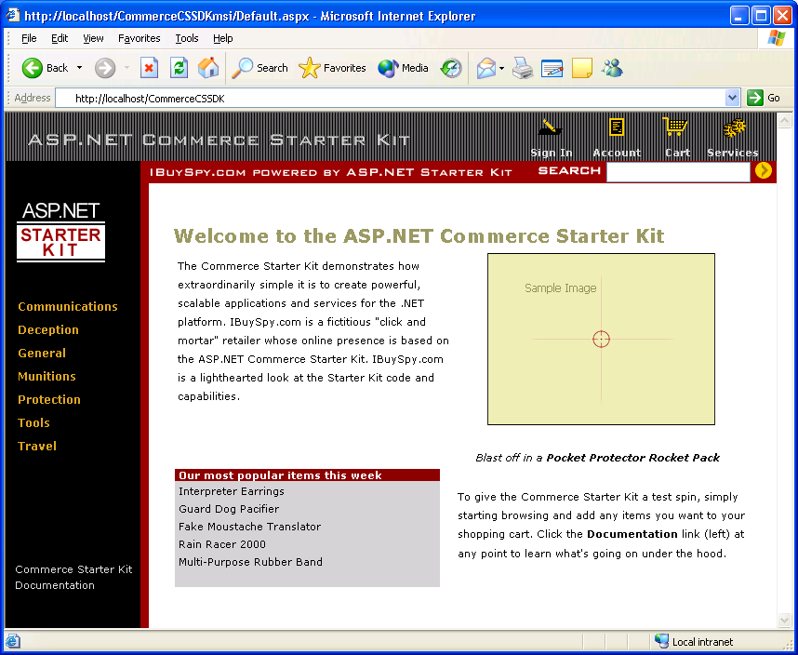
The Commerce Starter Kit demonstrates many features offered by the ASP.NET technology including:
- Cross-browser support for Netscape and Internet Explorer
- Clean code/html content separation using server controls
- High performance catalog pages that use output caching
- 3-tier ADO.NET data access using SQL stored procedures
- Forms authentication using a database for usernames/passwords
- SOAP XML web services for B2B order entry and status
This white paper discusses the Commerce Starter Kit in depth and provides insight from the perspective of the creators. In addition, the article covers how the Commerce Starter Kit can be used as a template for building e-commerce storefronts by examining many of the key application features and the technology used to implement them.
The Commerce Starter Kit was developed in both in-line and code behind versions. The SDK version is coded in-line and is optimized for the ASP.NET Web Matrix Project and the .NET Framework SDK. The second version was written using Microsoft ® Visual Studio.NET™ using the code-behind coding model. Both versions contain implementations written in C# and VB.NET.

Application Architecture
Distributed web applications traditionally are designed and built across three logical tiers:
- Database Access Layer (DAL)
- Business Logic Layer (BLL)
- Presentation Layer
The DAL refers to the database itself, the stored procedures, and the component that provides an interface to the database. The BLL refers to the component that encapsulates all the business logic of the application. And, the Presentation layer refers to the web application pages.
Building distributed applications using the .NET technologies still relies on well designed logical three-tier architectures. The Commerce Starter Kit was built with this same concept in mind, with one exception. To reduce the complexity of the application, the BLL and the DAL were combined into a single layer. Rather than create simple pass through methods on the business logic component, we opted to combine the two layers. Figure 1 illustrates the Store architecture.
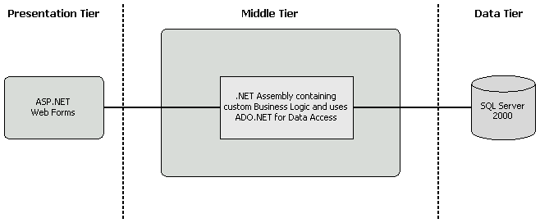
Figure 1. Commerce Starter Kit

Database
This section will describe the database for the Commerce Starter Kit. We will begin by providing some information on how the database was designed. After that, we will discuss our implementation including the detailed explanation of the database schema and stored procedures.

Creating the Data Model
When you create your application, it is best to create your application from the data up. This means that when you start designing your application, it is important to first identify the different tables and fields you will need, which will later pave the way for building the rest of the application. As an example, for the Commerce Starter Kit we identified the 7 tables, which are described in detail in the next section. Of these tables, 6 of them are directly translated into 6 corresponding classes. We will discuss this more in the next section as well.

Database Schema
In order to design the database schema, we needed to look at the requirements of the application. In our application, we are going to have a product catalog that customers can browse and add items to their shopping cart. In addition, they can add product reviews that other customers can view.
We also want to create some additional cross-selling features like a “Customers who have purchased this item also purchased” list. A “top products purchased” is also to be implemented in the system.
So, taking these high level requirements, we can quickly and easily identify the tables and stored procedures in our database by simply identifying many of the verbs and nouns in some user cases:
- Customers can add a given product to the shopping cart.
- Customers can add a review for a product.
- Customers can view products by category.
- Customers can checkout the shopping cart to place an order.
Out of these user cases, we can identify a number of objects, which are nouns in our sentences.
- Customers
- Products
- Shopping Cart
- Reviews
- Categories
- Orders
Taking these objects, we can easily identify our main tables in the database. The physical schema is show in Figure 2.
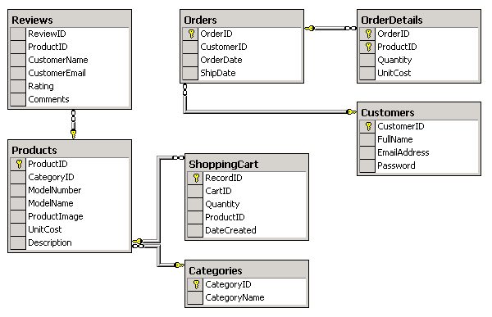
Figure 2. Physical Database Schema

Stored Procedures
The Commerce Starter Kit uses stored procedures to encapsulate all of the database queries. The use of stored procedures provides a clean separation between the database and the middle-tier data access layer. This in turn provides easier maintenance, since changes to the database schema will be invisible to the data access components. There are also additional performance benefits by using stored procedures because they are optimized the first time they are run and then retained in memory for subsequent calls.
A good example of one of the more complicated stored procedures in the Commerce Starter Kit is the “ShoppingCartAddItem” stored procedure. This procedure is responsible for adding a product to the customer’s shopping cart.

ShoppingCartAddItem
CREATE Procedure ShoppingCartAddItem
(
@CartID nvarchar(50),
@ProductID int,
@Quantity int
)
As

Declare @CountItems int

SELECT @CountItems= Count(ProductID)
FROM ShoppingCart
WHERE ProductID= @ProductID AND CartID= @CartID

IF @CountItems > 0 /* There are items - update the current quantity */
UPDATE ShoppingCart
SET Quantity= (@Quantity + ShoppingCart.Quantity)
WHERE ProductID= @ProductID AND CartID= @CartID
ELSE /* New entry for this Cart. Add a new record */
INSERT INTO ShoppingCart
(CartID, Quantity, ProductID)
VALUES
(@CartID, @Quantity, @ProductID)
GO

Database Access Layer
The Commerce Starter Kit uses a middle-tier component to provide communication between the ASP.NET Web Forms and the SQL Server database. This section describes the implementation of this data access component.

ASP.NET Commerce Starter Kit Namespace
In the section “Creating the Data Model”, we stressed the importance of developing the application from the data up. Implementing the data access component is straight forward by taking a data-centric view of the application and by creating the database schema first. Our component will contain the following classes, which maps to our database tables.
- CustomersDB
- ProductsDB
- ShoppingCartDB
- ReviewsDB
- OrdersDB
In Microsoft .NET, you can group your classes together into a namespace which organizes your component. In the Commerce Starter Kit, we created a namespace called ASPNET.StarterKit.Commerce, which would hold all of the classes above. The namespace is defined as “ASPNET.StarterKit.Commerce” and has the following structure shown in Figure 3:

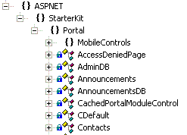
Figure 3. ASPNET.StarterKit.Commerce namespace
Namespaces do not necessarily have to be contained within one file. In the Commerce Starter Kit, we created a source file for each class (with the exception of OrderDetails and Orders) and compiled all of the source files into one assembly, ASPNETCommerce.dll.

App Settings
Before we jump to the data access, we have some housekeeping to do. In order to establish a connection to SQL Server, the middle-tier component requires the necessary connection information in order to connect to the database. A connection string is used to provide the connection information to the database. The connection string needs to be supplied to the to the connection object for every database query.
One option would be to be to define a constant to hold this connection string and put it in the component itself. However, this should be avoided in practice because if the connection string changes (i.e. location changes, password changes, etc) than we will need to recompile the component, which is not desirable. To prevent this unnecessary recompiling, the connection string can be placed in the AppSettings section of the web application’s configuration file, web.config (located in the root of the web application’s virtual directory).
<configuration>
<appSettings>
<add key="ConnectionString"
value="server=localhost;uid=sa;pwd=;database=store" />
</appSettings>
</configuration>
This configuration information can be accessed via our database access layer using the ConfigurationSettings class in the System.Configurations namespace.
m_ConnectionString =
(String) ConfigurationSettings.AppSettings["ConnectionString"];
This statement is placed in a public static property in our data access layer, so that we can retrieve the connection string anywhere in our component by using the following statement:
ASPNET.StarterKit.Commerce.ConnectionString
In addition to the maintenance benefits of storing the connection string in the web.config, the performance of the application is not compromised because the string is cached and is retrieved from the web.config only when there is a change.

Common Pattern
The Commerce Starter Kit uses the new managed provider for SQL Server for optimal performance. The majority of the methods in the data access component follow a very similar pattern. The patterned is outlined as follows:
- Create Connection to the Database
- Create Command Object
- Set Command Type to Stored Procedure
- Create and Populate Parameters
- Execute the Command
- Close the Connection
A good example of this is the GetProducts() method in the ProductsDB class:

GetProducts Method
public SqlDataReader GetProducts(int categoryID)
{
// Create Instance of Connection and Command Object
SqlConnection myConnection =
new SqlConnection(ASPNETCommerceDB.ConnectionString);

SqlCommand myCommand =
new SqlCommand("ProductsByCategory", myConnection);

// Mark the Command as a stored procedure
myCommand.CommandType = CommandType.StoredProcedure;

// Add Parameters to the stored procedure
SqlParameter parameterCategoryID =
new SqlParameter("@CategoryID", SqlDbType.Int, 4);
parameterCategoryID.Value = categoryID;
myCommand.Parameters.Add(parameterCategoryID);

// Execute the command
myConnection.Open();
SqlDataReader result =
myCommand.ExecuteReader(CommandBehavior.CloseConnection);

// Return the datareader result
return result;
}
One very important feature to note is the built in ability of the DataReader’s ExecuteReader method to close the connection when it is finished reading the data. This makes it very simple to open and read the data and not have to worry about closing the connection. As shown in the GetProducts() method, this functionality is achieved by passing CommandBehavior.CloseConnection as an argument to the ExecuteReader method.

DataReaders versus DataSets
One of the most common data access related questions that comes up concerns the difference between the DataReader and the DataSet. “When should I use a DataReader and when should I use the DataSet?”
The DataReader is a connected reader that provides a forward-only view of data. Because DataReaders are forward only, they are very fast at reading data, and therefore should be used in a majority of cases.
However, being a forward only connected reader also introduces a number of limitations. For example, if you need to support features such as paging and sorting you will not be able to use a DataReader without adding additional custom code. If you want to use the ASP.NET Cache API to store a particular result set for use in more than one page, you will not be able to use the DataReader. For these cases you should use the DataSet. In addition, if you need to pass the data around in the component layer or if you need to modify the enclosed data before you use it, you must also use the DataSet.
The Commerce Starter Kit uses the DataReader almost exclusively. This is because, as in most Web applications, the majority of the data in the Commerce Starter Kit is read only and we were interested in very fast access to the data. This is the most ideal solution for the majority of scenarios, except for cases where you need functionality beyond a forward-only reader.

Compiling the Component
Compiling the middle-tier component will depend on which version of the application you are using (the Visual Studio.NET or the SDK). In both cases, the compilation process is very easy to do and has been automated.

Visual Studio.NET
Inside of the Visual Studio.NET IDE, you can simple go to the “Build” menu and select rebuild to recompile the middle-tier component.

.NET Framework SDK
The Commerce Starter Kit comes with a batch file that can be used to recompile the middle-tier component when you are running the application without Visual Studio .NET installed. This batch file is called mk.bat and it is located in the Components directory. If you modify any of the component source files, you will need to recompile them to update the Store.dll library.
You can also compile the component without the batch file. To do this you will use the Visual Basic.NET command line compiler (or the C# compiler is you are working the C# implementation).
The Visual Basic.NET command line compiler is a file called vbc.exe. To get a list of all the compiler options, type vbc at a command prompt. Table 1 summarizes the key compiler options you will need to compile your components.
Compiler Option | Description
/out:<file> | Specifies the output file name
/target:<type> | Specifies the target type (Short form: /t)  library (library assembly, dll)  exe (console application)  winexe (windows application)  module (module to add to an assembly)
/reference:<file_list> | Reference metadata from the specified assembly (Short form: /r)
Table 1. Compiler Command Line Parameters
A common example format for compiling a library assembly, which is what we are building in the Commerce Starter Kit would be in the following format:
vbc /out:..\bin\MyLibrary.dll /t:library /r:System.Data.dll Source.cs
This example would compile the source code in the file Source.cs, reference the System.Data namespace, and generate the library named MyLibrary.dll up a directory and in the bin folder.

Web Application Design
The presentation layer for the Commerce Starter Kit was built using ASP.NET Web Forms. This section will describe how ASP.NET was used to implement a number of the key features of the Commerce Starter Kit.

The Login Page
A basic task with most web-applications is user authentication. ASP.NET offers a variety of built in user authentication system schemes. The Commerce Starter Kit makes use of the FormsAuthentication (described in more depth in the “Security and Deployment” section), which can be seen in the following source code for Login.aspx.
// Save old ShoppingCartID
ASPNET.StarterKit.Commerce.ShoppingCartDB shoppingCart = new ASPNET.StarterKit.ShoppingCartDB();
String tempCartID = shoppingCart.GetShoppingCartId();

// Attempt to Validate User Credentials using CustomersDB
ASPNET.StarterKit.CustomersDB accountSystem = new ASPNET.StarterKit.CustomersDB();
String customerId = accountSystem.Login(email.Text, password.Text);

if (customerId != null)
{
// Migrate any existing shopping cart items into the
// permanent shopping cart
shoppingCart.MigrateCart(tempCartID, customerId);

// Lookup the customer's full account details
ASPNETCommerce.CustomerDetails customerDetails =
accountSystem.GetCustomerDetails(customerId);

// Store the user's fullname in a cookie for personalization purposes
Response.Cookies["ASPNETCommerce_FullName"].Value = customerDetails.FullName;

// Make the cookie persistent only if the user selects
// "persistent" login checkbox
if (RememberLogin.Checked == true)
{
Response.Cookies["ASPNETCommerce_FullName"].Expires =
DateTime.Now.AddMonths(1);
}

// Redirect browser back to originating page
FormsAuthentication.RedirectFromLoginPage(customerId,
RememberLogin.Checked);
}
else
{
Message.Text = "Login Failed!";
}
The first step of the login process is to save the current shopping cart id, so the cart contents can be migrated to the permanent cart for the logged in user. Once this is completed, the user’s login information is validated against the database. If validated, the full customer information is retrieved and their full name is stored in a cookie for personalization purposes. An expiration date is set for the cookie if the user has specified to “remember login”, otherwise the cookie will be destroyed when the user ends the session. After these steps are completed, the RedirectFromLoginPage method is invoked, which issues an authentication ticket to the client and redirects the user back to the page they were attempting to access.

Product Listing
The ASP.NET Server Controls are a collection of rich controls that are aimed toward improving encapsulation of code and increasing productivity. There are three types of server controls: HTML Controls, Forms Controls and Bound List Controls. Declaring a Server Control is quite easy as shown:
<asp:Label id="MyLabel" class="MyLabelText" runat="server" />
The “id” attribute identifies the Server Control and the “runat” attribute indicates that it is a Server Control.
The HTML Controls should be used for forms that are already developed using the existing HTML elements, and the Forms and List Controls should be used for new web forms.
The Product Listing screen is a great example of using the Bound List Controls. The page contains a DataList control, which allows developers to easily display contents of a data source, in this case, product information. The DataList contains a number of templates that can be set which will give developers the ability to control how the data is rendered in the control.
In addition to simply rendering the data source, the DataList offers a number of rich features that will help increase productivity. In the case of the Product Listing, we want to display two columns of products. This is achieved by setting one property on the DataList, RepeatColumns. This is just one example of the rich functionality that the ASP.NET List Controls offer. The code for the DataList is displayed below in Listing XX.
<asp:DataList id="MyList" RepeatColumns="2" runat="server">
<ItemTemplate>
<table border="0" width="300">
<tr>
<td width="25">
&nbsp;
</td>
<td width="100" valign="middle" align="right">
<a href='ProductDetails.aspx?productID=<%# DataBinder.Eval(Container.DataItem, "ProductID") %>'>
<img src='ProductImages/thumbs/<%# DataBinder.Eval(Container.DataItem, "ProductImage") %>' width="100" height="75" border="0">
</a>
</td>
<td width="200" valign="middle">
<a href='ProductDetails.aspx?productID=<%# DataBinder.Eval(Container.DataItem, "ProductID") %>'>
<span class="ProductListHead">
<%# DataBinder.Eval(Container.DataItem, "ModelName") %>
</span>
<br>
</a><span class="ProductListItem"><b>Special Price: </b>
<%# DataBinder.Eval(Container.DataItem, "UnitCost", "{0:c}") %>
</span>
<br>
<a href='AddToCart.aspx?productID=<%# DataBinder.Eval(Container.DataItem, "ProductID") %>'>
<span class="ProductListItem"><font color="#9D0000">
<b>Add To Cart<b></font></span>
</a>
</td>
</tr>
</table>
</ItemTemplate>
</asp:DataList>

The ASP.NET Commerce Starter Kit Menu
User Controls are custom UI widgets that encapsulate functionality. They can be used to increase productivity through code reuse. User Controls are similar to traditional Server Side Includes, only much more powerful and flexible. User Controls can contain properties and encapsulate logic that can be exposed to the Web Forms that include them. This allows developers to create smart User Controls that can be reused for a number of different applications, but still contain portions that are customized for each application.
The Commerce Starter Kit contains a number of User Controls that are reused throughout the application. One example of these controls is the menu user control. The menu is responsible for displaying a list of links that correspond to product categories. We chose a DataList to implement the menu’s contents, since it would allow us to display the selected item differently to the user so they knew what category they were browsing.
A User Control is added to a Web Form by adding a Register directive for the User Control. The directive contains three attributes: TagPrefix, which provides a unique namespace for the user control; TagName, which provides a unique name for the User Control; and Src, which contains the virtual path to the User Control. The Register directive to add the Menu User Control is shown below.
<%@ Register TagPrefix="ASPNETCommerce" TagName="Menu" Src="_Menu.ascx" %>
Once you have added the Register directive to your page, you next need to define where on the page you want the User Control to appear. You do this by adding the User Control tag within the Web Form’s UI. The tag for the Menu control would look like the following:
<ASPNETCommerce:Menu id="Menu1" runat="server" />

Shopping Cart
One of the rich features of the DataGrid control is the ability to perform inline editing. This is done by defining a column as a TemplateColumn and filling it with another ASP.NET Server Control, such as a TextBox or CheckBox. An example of this is demonstrated in the Commerce Starter Kit shopping cart shown in Figure 4.
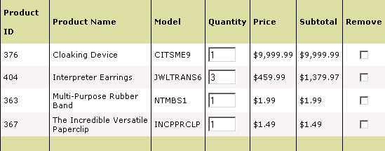
Figure 4. Shopping Cart
By default, the DataGrid adds columns automatically for each field in the data source. The columns in the DataGrid can be customized by setting the AutoGenerateColumns property to false and manipulating the grid’s Columns collection. The shopping cart’s DataGrid implementation demonstrates this:
<asp:DataGrid
id="MyList"
runat="server"
BorderColor="black"
GridLines="Vertical"
cellpadding="4"
cellspacing="0"
Font-Name="Verdana"
Font-Size="8pt"
ShowFooter="true"
HeaderStyle-CssClass="CartListHead"
FooterStyle-CssClass="CartListFooter"
ItemStyle-CssClass="CartListItem"
AlternatingItemStyle-CssClass="CartListItemAlt"
DataKeyField="Quantity"
AutoGenerateColumns="false">
<Columns>
<asp:TemplateColumn HeaderText="Product&nbsp;ID">
<ItemTemplate>
<asp:Label id="ProductID" runat="server" Text='<%#
DataBinder.Eval(Container.DataItem, "ProductID") %>' />
</ItemTemplate>
</asp:TemplateColumn>
<asp:BoundColumn HeaderText="Product Name" DataField="ModelName" />
<asp:BoundColumn HeaderText="Model" DataField="ModelNumber" />
<asp:TemplateColumn HeaderText="Quantity">
<ItemTemplate>
<asp:TextBox id="Quantity" runat="server" Columns="4" Text='<%#
DataBinder.Eval(Container.DataItem, "Quantity") %>'
width="40px" />
</ItemTemplate>
</asp:TemplateColumn>
<asp:BoundColumn HeaderText="Price" DataField="UnitCost"
DataFormatString="{0:c}" />
<asp:BoundColumn HeaderText="Subtotal"
DataField="ExtendedAmount" DataFormatString="{0:c}" />
<asp:TemplateColumn HeaderText="Remove">
<ItemTemplate>
<center>
<asp:CheckBox id="Remove" runat="server" />
</center>
</ItemTemplate>
</asp:TemplateColumn>
</Columns>
</asp:DataGrid>

Cross-Browser Support
Typical web applications are also have broad requirements for supporting various browsers such as Internet Explorer and Netscape as well as previous version (for instance having the application work in Internet Explorer 4.0 and above is still very common). Maintaining a consistent look and feel between Internet Explorer and Netscape Navigator is critical in keeping a unified experience across the various browsers.
Here are some tips to keep in mind:
- Use CSS
- Careful about CSS class name casing – Navigator 6 cares
- For inputs, must add Size attribute for Navigator
It is also important to test as you are developing the pages in all of the target browsers as you go.

Performance
You can greatly improve the performance of your applications by utilizing the caching abilities of ASP.NET. There are three types of caching available in ASP.NET, Output Caching, Fragment Caching, and Data Caching. The first type, Output Caching, allows the contents of a page (after it has been parsed on the server and rendered as HTML) to be stored in a cache and returned to HTTP requests without additional re-rendering of the page for a give period of time. Fragment Caching will cache a specific region of page for a designated length of time. Finally, Data Caching provides an API that allows direct access to the cache.
Fragment Caching is used throughout the Commerce Starter Kit application. An example of Fragment Caching is demonstrated in the Menu User control. At the top of the _menu.ascx page, you will see the following directive, which enables Fragment Caching for the User Control.
<%@ OutputCache Duration="3600" VaryByParam="Selection" %>
The Duration attribute instructs ASP.NET to cache the _menu.ascx User Control for 3600 seconds. The VaryByParam allows you to specify different instances of the control in the cache. This way you can still cache User Controls that vary depending on public properties. In this case, the VaryByParam is set to “Selection”, which means several copies of the menu control – each showing a different selection – will be stored in the cache.

Security and Deployment
The Commerce Starter Kit contains an automated setup process that allows it to be deployed to single machine or a full-blown data center. There are numerous considerations to keep in mind when deploying and securing web applications that impact the operations side (like updating the sight and making configuration changes) as well as on an application level (i.e., the performance of the application).

Forms-Based Authentication
ASP.NET offers a built in authentication system known as Forms-Based Authentication. With this system, you specify a login page in the web.config’s authentication section. The authentication section for the Commerce Starter Kit:
<system.web>
<authentication mode="Forms">
<forms name="ASPNETCommerceAuth"
loginUrl="login.aspx"
protection="All" path="/" />
</authentication>
</system.web>
You next add a location section for each page that requires authentication. The following is an example for the “Checkout.aspx” page.
<location path="Checkout.aspx">
<system.web>
<authorization>
<deny users="?" />
</authorization>
</system.web>
</location>
The path tells the system what file to require authentication for. The portion <deny users=”?” /> indicates that all unauthenticated users will be denied access to the page. When an unauthenticated user attempts to view the page, they are immediately redirected to the login page, which we defined above. After the user provides the necessary credentials, the login page authenticates the user and redirects them back to the page they attempted to view.
FormsAuthentication.RedirectFromLoginPage(customerId,
RememberLogin.Checked);

Deploying
The updated deployment process is one of the most impressive features offered by the Microsoft .NET Framework. In the past, deploying the database layer and the presentation layer were not that big of a deal, however, deploying the components required registration of the component on the server. This introduced a number of issues that seemed to always crop up, including the popular state known as “DLL Hell” where you ran into issues with other applications and components being dependent on a different version of the component.
Microsoft .NET solves this by eliminating registration all together. Components, more correctly referred to as assemblies, are now self-describing with eliminates the need to store information about the assembly in the registry. This means that when you install a .NET application, you simply copy and paste the component in the application’s bin directory. The metadata within the assembly provides the all of the information that is needed for an application to locate use the component.

Web Farming
For the most part, the Commerce Starter Kit supports web farming “as is.” This means that you will be able to install the application on a number of servers, and have the cluster distribute the load with each other. The only issue that requires configuration is the authentication.
When you log into the storefront, ASP.NET authentication creates a browser cookie that is set and read by the server. Once you have logged in, if you browse to a page that requires authentication, the server looks for that cookie, and if it finds it allows you to view that page.
When you consider a web-farm scenario, users can log in using one server (which means a cookie is created for that server), but then request a page that requires authentication from another server on the farm (which doesn’t have a cookie). Depending on the session affinity settings of the load balancing solution, this could result in having to log in every time you hit a different web server. To prevent this, you must modify the Commerce Starter Kit to share the cookie across all servers (or turn on session affinity).
By default the authentication cookie’s decryption key is set to “autogenerate” which means the decryption key is set to a random key dependent to that server. This means, that the servers will not be able to use each other’s cookie. This can be solved by manually setting the decryption key to be the same key on all servers in the web farm. You set the decryption key with the following element in the web.config.
<machineKey decryptionKey="213454ABE333321D" />
The decryption key was selected at random; it just needs to be the same in each server’s web.config file. The default protection level for the Form’s based authentication setting was also changed from “All” to “None”.
<authentication mode="Forms">
<forms name="ASPNETCommerceAuth"
loginUrl="login.aspx" protection="None" />
</authentication>

Conclusion
The development of distributed web applications has been greatly simplified by the Microsoft .NET technologies. ASP.NET Web Forms, caching capabilities, and simplicity of data access in .NET enhance the overall application development process from turning business requirements into middle-tier components to deployment and maintenance. In addition to demonstrate several of the key new .NET technologies, the Commerce Starter Kit application also serves to provide a template for building online e-commerce applications.

For More Information
- The complete documentation and source code can be obtained at http://www.asp.net
- For a live version of the site, please visit http://www.asp.net
- IBuySpy Listserver http://www.aspfriends.com/aspfriends/aspngibuyspy.asp
- For a complete list of ASP.NET resources, please visit http://www.asp.net

